Question 40-2B:
Q: Write the formula for a variance and the formula for a covariance.
You may write these formulas without using subscripts.
A: sum(x-xbar)^2/(n- 1)
A: sum((x-xbar)(y-ybar))/(n- 1)
Question 41-2B:
Q: Think about the formulas for variance and covariance. Which of the following is
NOT part of the formula for a covariance?
A: squaring values (option A)
Question 42-2B:
Q: A correlation is equal to _____ divided by _____ . What goes in the first blank?
What goes in the second blank?
1st blank: a covariance (option C)
2nd blank: the highest possible value a covariance could take (option D)
Question 43-2B:
Q: Use “cov_xy” as the symbol for the covariance between x and y and write the
formula for a correlation.
A: cov_xy/(sd_x)(sd_y)
-----------------------------------------------------LA 6---------------------------------------------------
Question 44-2C:
Question 45-2C:
Question 46-2C:
Question 47-2C:
Question 48-2C:
Question 49-2C:
Question 50-2C:
-----------------------------------------------------LA 7---------------------------------------------------
Question 51-2D:
Q: What is a linear equation that includes an “e” where the average deviation of |e| is the standard error of measure?
A: x_ai=true_i+e_ai
Question 52-2D:
Fill in each blank by typing correctly spelled words that match the words used in the googly-eyed sheep table (the one titled, “Types of distributions”). A standard error of measure pertains to:
Q: Observations of different __?___ from a single __?___. Deviations around a __?___.
1st blank: assessments
2nd blank: case
3rd blank: true score
Question 53-2D:
Q: Write the definition of the standard error of measure.
A: “If you test me many times, my scores will change and stray from true, the standard error of measure says just how far they do”
Question 54-2D:
Q: In the equation, x = true + e, the “e” needs a subscript to indicate it belongs to ___
Q: If Cronbach’s α is .6, it indicates that ____
1st blank: assessment occasion “a” for individual “i” (option “C.”)
2nd blank: 60% of the variance is true variance (option “D.”)
-----------------------------------------------------LA 8---------------------------------------------------
Question 55-2E:
Q: Write the linear equation that includes an “e” where the average deviation of |e| is the standard error of a mean. Note: The equation should include subscripts.
A: xbar_sp=mu_p+e_sp
Question 56-2E:
Fill in each blank by typing correctly spelled words that match the words used in the googly-eyed sheep table (the one titled, “Types of distributions”). A standard error of a mean pertains to:
Q: Observations of different __?__ from a single __?__. Deviations around a __?__.
1st blank: samples
2nd blank: population
3rd blank: population parameter
Question 57-2E:
Q: Write the linear equation that includes an “e” where the average deviation of |e| is the standard error of a difference between means. Note: Equations should include subscripts.
A: (ybar-ybar)_sp=(mu-mu)_p+e_sp
Question 58-2E:
Fill in each blank by typing correctly spelled words that match the words used in the googly-eyed sheep table (the one titled, “Types of distributions”). A standard error of a difference between means pertains to:
Q: Observations of different __?__ from a single __?__. Deviations around a __?__.
1st blank: samples
2nd blank: population
3rd blank: population parameter
Question 59-2E:
Q: Write the linear equation that includes an “e” where the average deviation of |e| is the standard error of a beta. Note: Equations should include subscripts. If you need to use Greek letters, remember that: 𝛍 = mu 𝛃 = beta 𝛒 = rho
A: B_sp=beta_p+e_sp
Question 60-2E:
Fill in each blank by typing correctly spelled words that match the words used in the googly-eyed sheep table (the one titled, “Types of distributions”). A standard error of a beta pertains to:
Q: Observations of different __?__ from a single __?__. Deviations around a __?__.
1st blank: samples
2nd blank: population
3rd blank: population parameter
Question 61-2E:
Q: Write the linear equation that includes an “e” where the average deviation of |e| is the standard error of a correlation. Note: Equations should include subscripts. If you need to use Greek letters, remember that: 𝛍 = mu 𝛃 = beta 𝛒 = rho
A: r_sp=rho_p+e_sp
Question 62-2E:
Fill in each blank by typing correctly spelled words that match the words used in the googly-eyed sheep table (the one titled, “Types of distributions”). A standard error of a correlation pertains to:
Q: Observations of different __?__ from a single __?__. Deviations around a __?__.
A-Blank #1: samples
A-Blank #2: population
A-Blank #3: population parameter
Question 63-2E:
Correctly spell a single word that goes in each blank. When writing linear equations (for the standard deviation, standard error of estimate, standard error of measure, and standard error of a statistic), you need to use the subscripts, “i,” “s,” “a,” and “p.”
Q: “i” stands for _______ . “s” stands for _______ . “a” stands for _______ . “p” stands for _______ .
1st blank: individual
2nd blank: sample
3rd blank: assessment
4th blank: population
Question 64 Set 2 E
Q: Write the definition of a standard error of a statistic. Your definition should state the most important things to know about a standard error of a statistic. You may write the lyrics to the song or paraphrase the key points that were made in the song.
A: How much change do you typically find…if a study is repeated many times?
…Each statistic we declare, will have its own standard error.
Question 65-2E:
Q: The smaller the sample ___ .
Q: The standard error of a correlation indicates how far correlations from different studies typically deviate from ___ .
1st blank: the larger the standard error of a statistic (“Option D.”)
2nd blank: the population parameter (Option A.”)
Question 66-2E:
Correctly spell the term that goes in the blank.
Q: The size of the standard error of a statistic is primarily influenced by the size of the _______ .
A: sample
Question 67-2E:
Correctly spell the term that goes in the blank.
Q: Standard error of a statistic will be almost perfectly _______ in shape.
A: normal
---------------------------------------------------LA 9-----------------------------------------------------Question 68-2F:
Q: …
A: …
Question 69-2F:
Q: …
A: …
Question 70-2F:
Q: …
A: …
Question 71-2F:
Q: …
A: …
---------------------------------------------------LA 10--------------------------------------------------
Question 72-3A:
Q: For a single sample estimate of a single mean, write the linear equation for variance in a sample. Note: The equation should include subscripts.
A: x_is=xbar_s+e_is
Question 73-3A:
Q: For a single sample estimate of a single mean, write the linear equation for sampling error variance in a population. Note: The equation should include subscripts.
A: xbar_sp=mu_p+e_sp
Question 74-3A:
Correctly spell the terms that go in the blanks. The equation x_is=xbar_s+e_is includes two types of components.
Q: First, a _____ is a value that can vary between people in sample.
Q: Second, a _____ is a value that can vary between studies in a population
1st blank: variable
2nd blank: parameter estimate
Question 75-3A:
Consider the two equations below
x_is=xbar_s+e_is
xbar_sp=mu_p+e_sp
Q: Which of the following are variables? Select ALL the correct answers
1st answer: x_is (option “A.”)
2nd answer: e_is (option “E.”)
Question 76-3A:
Consider the two equations below
x_is=xbar_s+e_is
xbar_sp=mu_p+e_sp
Q: Which of the following are parameter estimates? Select ALL the correct answers
A: xbar_s (option “C.”)
Question 77-3A:
Consider the two equations below
x_is=xbar_s+e_is
xbar_sp=mu_p+e_sp
Q: Which of the following answers the descriptive question and would provide the primary result we want to know when conducting a study?
A: xbar_s (option “C.”)
Question 78-3A:
Consider the two equations below
x_is=xbar_s+e_is
xbar_sp=mu_p+e_sp
Q: Which of the following is the primary component that we need to use to answer the inferential question?
A: e_sp (option “D.”)
Question 79-3A:
Consider the two equations below
x_is=xbar_s+e_is
xbar_sp=mu_p+e_sp
Match each definition with the appropriate term in the box:
Possible terms: standard error of measure, standard deviation, standard error of estimate, standard error of a statistic, z-score, t-value
Q: The average deviation of |e_is|.
Q: The average deviation of |e_sp|.
1st definition: standard deviation
2nd definition: standard error of a statistic
Question 80-3A:
Consider the equation:
xbar_sp=mu_p+e_sp
Assume you want to know the standardized e_sp for a particular study assuming the null hypothesis is true.
Q: This can be answered with:
A: a t-value (option “C.”)
Question 81-3A:
Q: The standard of the error of the mean will be the largest when the standard deviation is ________ and the sample size is ________ .
Q: Which of the following will produce the largest standard error of the mean?
1st answer: large, small (option “B.”)
2nd answer: sd = 8, and the sample size is small (option “C.”)
Question 82-3A:
Linear equations:
x_is=xbar_s+e_is
xbar_sp=mu_p+e_sp
You are given the following:
xbar_s=10 sd=2.12 sd_xbar=.95 n=5 t=10.53
Q: If H0 is true, how many standard error units did this study deviate from the null population parameter?
Q: What is the average deviation of |e_is| ?
1st answer: 10.53
2nd answer: 2.12
Question 83-3A:
Linear equations:
x_is=xbar_s+e_is
xbar_sp=mu_p+e_sp
You are given the following:
xbar_s=10 sd=2.12 sd_xbar=.95 n=5 t=10.53
Q: What is the average deviation of |e_sp| ?
Q: If H0 is true, what is the standardized e_sp for this particular study?
1st answer: .95
2nd answer: 10.53
Question 84-3A:
Linear equations:
x_is=xbar_s+e_is
xbar_sp=mu_p+e_sp
You are given the following:
xbar_s=10 sd=2.12 sd_xbar=.95 n=5 t=10.53
Q: Which numerical value answers the descriptive question and provides the primary result the researcher wanted to know when conducting this study?
A: 10
Question 85-3A:
Linear equations:
x_is=xbar_s+e_is
xbar_sp=mu_p+e_sp
You are given the following:
xbar_s=10 sd=2.12 sd_xbar=.95 n=5 t=10.53
Q: To look up the probability of these results assuming the null hypothesis is true, you need to use two numerical values. One of these values is equal to 4. What is the other numerical value you need to use?
A: 10.53
---------------------------------------------------LA 11--------------------------------------------------
Question 86-3B:
Q: …
A: …
Question 87-3B:
Question 88-3B:
Question 89-3B:
Question 90-3B:
Question 91-3B:
Question 92-3B:
Question 93-3B:
---------------------------------------------------LA 12--------------------------------------------------
Question 94-3C:
Q: …
A: …
Question 95-3C:
Question 96-3C:
Question 97-3C:
Question 98-3C:
Question 99-3C:
Question 100-3C:
Question 101-3C:
Question 102-3C:
Question 103-3C:
Question 104-3C:
Question 105-3C:
Question 106-3C:
---------------------------------------------------LA 13--------------------------------------------------
Question 107-3D:
Q: …
A: …
Question 108-3D:
Question 109-3D:
Question 110-3D:
Question 111-3D:
---------------------------------------------------LA 14--------------------------------------------------
Question 112-4A:
Q: …
A: …
Question 113-4A:
Question 114-4A:
Question 115-4A:
Question 116-4A:
Question 117-4A:
Question 118-4A:
---------------------------------------------------LA 15--------------------------------------------------
Question 119-4B:
Q: …
A: …
Question 120-4B:
Question 121-4B:
Question 122-4B:
Question 123-4B:
Question 124-4B:
Question 125-4B:
Question 126-4B:
Question 127-4B:
Question 128-4B:
---------------------------------------------------LA 16--------------------------------------------------
Question 129-4C:
Q: …
A: …
Question 130-4C:
Question 131-4C:
---------------------------------------------------LA 17--------------------------------------------------
Question 132-4D:
Q: …
A: …
Question 133-4D:
Question 134-4D:
---------------------------------------------------LA 18--------------------------------------------------
Question 135-5A:
Q: …
A: …
Question 136-5A:
Question 137-5A:
Question 138-5A:
Question 139-5A:
Question 140-5A:
Question 141-5A:
Question 142-5A:
Question 143-5A:
Question 144-5A:
---------------------------------------------------LA 19--------------------------------------------------
Question 145-5B:
Q: …
A: …
Question 146-5B:
Question 147-5B:
Question 148-5B:
Question 149-5B:
Question 150-5B:
---------------------------------------------------LA 20--------------------------------------------------
Question 151-5C:
If you want to know the effect of x_1 after controlling for x_2:
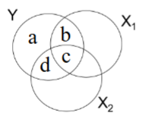
Q: In the Venn diagram, this pertains to ____ .
Q: The effect size is given by _____ .
Q: The significance of the effect is tested with _____
A: …
Question 152-5C:
Q: Using the letters from the Venn diagram above, type the formula that would be equal to a squared partial correlation between x_1 and y.
A: …
Question 153-5C:
Q: …
A: …
Question 154-5C:
Q: …
A: …
Question 155-5C:
You could calculate the partial correlation for x 1 above by using a simple regression equation in which [A] is used to predict [B].
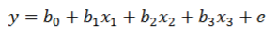
Q: What belongs in space A?
Q: What belongs in space B?
A: …
A: …
Question 156-5C:
Q: You calculate a statistic and get a value of .2 for x_1 and a value of .8 for x_2. The effect for x_1 might be larger than the effect for x_2 if the value you calculated is a …
Q: Which of the following is true about a standardized beta?
A: …
A: …
Question 157-5C:
Q: Which of the following is equal to area B divided by area A + B?
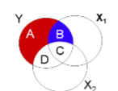
Q: What descriptive statistic would you calculate if you want to know the size of the standardized association between x 1 and y after controlling for other variables?
A: …
A: …
Question 158-5C:
Q: Which of the three things are equal to each other?
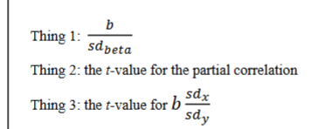
A: …
Question 159-5C:
Q: What does this formula do?
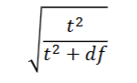
A: …
---------------------------------------------------LA 21--------------------------------------------------
Question 160-5D:
Q: The key difference between a partial correlation and a semipartial correlation has to do with:
A: …
Question 161-5D:
Q: Using the letters from the Venn diagram above, type the formula that would be equal to a squared semi-partial correlation between x1 and y.
A: …
Question 162-5D:
Q: Fill in the blank with a correctly spelled term: ΔR^2 is equal to R^2 full minus R^2 _______.
A: …
Question 163-5D:
Q: In the first step of an analysis, income and education were used to predict happiness. Which of the following are potential second steps that would allow the computation of ΔR^2? Select all examples that are potential second steps.
A: …
Question 164-5D:
Q: The table below displays correlations between four variables from a sample of 100 people. If you used all three x variables to predict y, which variables are likely to have significant beta weights?
A: …
Question 165-5D:
Q: Given these results, what best describes how results for Equation 2 are likely to compare with results for Equation 1?
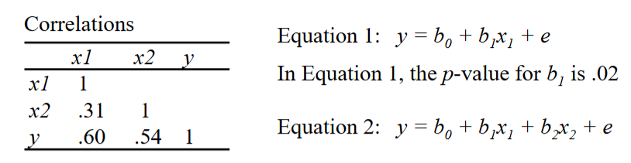
A: …
Question 166-5D:
Q: Given these results, what best describes how results for Equation 2 are likely to compare with results for Equation 1?
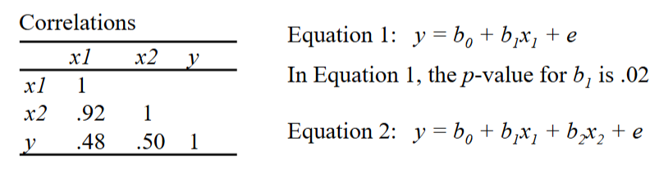
A: …
Question 167-5D:
Q: Pick the answer that would make this an example of a suppressor effect: The correlation between x 1 and y was .24 and significant. After controlling for x 2, the partial correlation between x 1 and y was ________ .
A: …
---------------------------------------------------LA 22--------------------------------------------------
Question 168-6A:
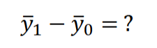
Q: The equation depicted above provides an example of ________ . (Select all the correct answers.)
1st correct option: A contrast (Option “A.”)
2nd correct option: A focused question (“Option B.”)
Question 169-6A:
Q: The values below include a grand mean and three groups means from a study contrasting three groups. Ollie Otter is in group 1. What is Ollie Otter’s predicted value on the outcome variable y?
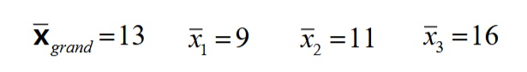
A: xbar_1=9
Question 170-6A:
Fill in each blank with a single word that is correctly spelled. When using ANOVA to test for differences between groups…
Q: the sum of squares explained is typically called the sum of squares ______ groups, and the sum of squared error is typically called the sum of squares _______ groups.
1st blank: between
2nd blank: within
Question 171-6A:
When using ANOVA to test for differences between groups the formula for the sum of squares for explained variance can be written as:
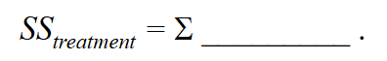
Q: Write the remaining part of the formula (just the part of the formula that appears after the Σ sign).
A: (ybar_group-ybar_grand)^2(n_group)
Question 172-6A:
Q: When using ANOVA to test for differences between groups the formula for the sum of squares for error variance can be written as:
Write the remaining part of the formula (just the part of the formula that appears after the Σ sign).
A: (y-ybar_group)^2
Question 173-6A:
Q: When using ANOVA to test for differences between groups the formula for the sum of squares for total variance can be written as:
Write the remaining part of the formula (just the part of the formula that appears after the Σ sign).
A: (y-ybar_grand)^2
Question 174-6A:
Q: Assume you are using ANOVA to test for differences between groups. If you have 5 groups, how many contrasts are free to vary?
A: 4
Question 175-6A:
Assume you are using ANOVA to test for differences between groups and you get the following results.
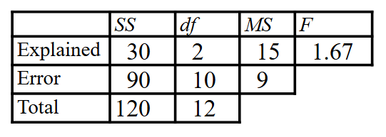
Q: What is standard deviation for y?
Q: What is the pooled within-group standard deviation for y?
Q: What is η2?
Q: How many groups were used in the analysis?
A: 3.16? sd_y=sqrt(SS_total/df_total))
A: 3 sqrt(SSerror/df_error) sqrt(MSerror) standard error of estimate
A: .25 SSexplained/SS total eta squared (“eta” is the same thing as “η”)
A: 3 number of groups df=p p=number of groups in analysis-1
Question 176-6A:
Q: sd_est is the same thing as:
A: the pooled within group sd
Question 177-6A:
Q: η^2 will be ______ R^2 and η^2 will be ______ ω^2.
1st blank: the same as
2nd blank: will be larger than
---------------------------------------------------LA 23--------------------------------------------------
Question 178-6B:
Correctly spell the term that belongs in the blank.
Q: The process of creating predictor variables with values that are determined by group membership is called _________ .
A: coding
Question 179-6B:
Q: Assume that x is group membership (coded such that 1 = treatment and 0 = control), and that a regression analysis with this variable produces the following results:
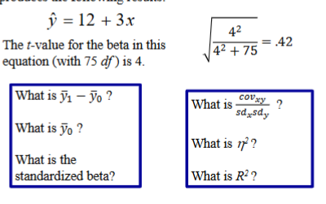
A: 3 b_1 ybar_1-ybar_0
A: 12 b_0 ybar_0
A: .42 rpb sb
A: .42 r rpb
A: .18 .42^2 r^2 eta^2
A: .18 .42^2 r^2 R^2
Question 180-6B:
Q: Assume that x is group membership (coded such that 1 = treatment and 0 = control), and that a regression analysis with this variable produces the following results:
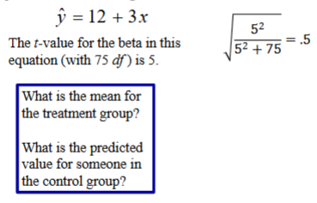
A: 15 12+(3)(1)
A: 12 12+(3)(0)
Question 181-6B:
Q: Assume that x is group membership (coded such that 1 = treatment and 0 = control), and that a regression analysis with this variable produces the following results:
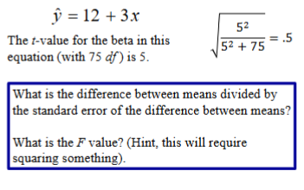
A: 5? t-value
A: 25? t^2 F

---------------------------------------------------LA 24--------------------------------------------------
Question 182-6C:
Q: If a researcher wants to create orthogonal contrasts for a study comparing 5 groups, how many contrasts does the researcher need to create?
A: …
Question 183-6C:
Q: …
A: …

---------------------------------------------------LA 25--------------------------------------------------
Question 192-6D:
You do a study with many groups and gets these ANOVA results.
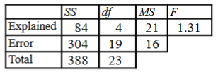
Q: If you wanted to do a t-test for a contrast between just Group 1 and Group 2, you would need the formula below. However, because there are more than 2 groups in this study, you would need to replace 𝑠𝑑^2_pooled with a value that can be calculated using the results above. What is this value?
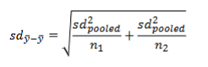
A: 16 replace sd^2_pooled with MSerror
Question 193-6D:
You do a study with many groups and gets these ANOVA results.
Q: If you wanted to do a t-test for a contrast between just Group 1 and Group 2, what are the appropriate degrees of freedom to use for this t-test?
A: 19
Question 194-6D:
Q: A researcher conducted 20 different t-tests, and in every case the null hypothesis was true. What is the best guess for how many of those t-tests were significant?
A: 1
Question 195-6D:
Dug the dog used t-tests to test contrasts between pairs of groups in a study with 4 groups. The results for the contrast between Group 1 and Group 2 are: t (230) = 2.5, p = .02.
Q: If Dug the dog made all the possible contrasts between group pairs, what is the p value for this contrast after a Bonferroni correction?
Q: If Dug the dog tested only a set of planned comparisons following standard procedures for orthogonal contrasts, what is the p value for this contrast after a Bonferroni correction?
1st A: .12 .02*4(4-1)/3 Bonferroni=p*k(k-1)/3
2nd A: .06 .02*3 p*number of pairs tested
Question 196-6D:
Keeping in mind the fact that the most stringent procedures for protecting against family-wise error will produce the largest p-values, fill in the blanks to reflect the most likely outcome.
A researcher used three different methods to protect against family-wise error and got p-values of .07, .04, and .02. It is most likely that:
Q: _____ produced a p-value of .07
Q: _____ produced a p-value of .04
Q: _____ produced a p-value of .02
1st A: A Bonferroni correction (Option “B.”)
2nd A: A Turkey Honestly Significant Difference test (Option “C.”)
3rd A: Fisher’s Least Significant Difference procedure (Option “A.”)
Question 197-6D:
Q: Post hoc analysis is used to test all the possible paired group contrasts. What is the name of the inferential statistic that can be used to determine if the difference between Group 2 and Group 3 is significant?
A: q (Option “C.”)

-------------------------------------------------LA 26-27---------------------------------------------

Not on study guide: LA #26 includes HW #6 questions, and LA #27 covers NO NEW COTENT

